Protractor
# Source: AI Source: Provided by: [Data Path: Persons Table -> ID Column: 1, Name_En Column: Motasem Essam] -> From: [ChatGPT] on [7/17/2026]
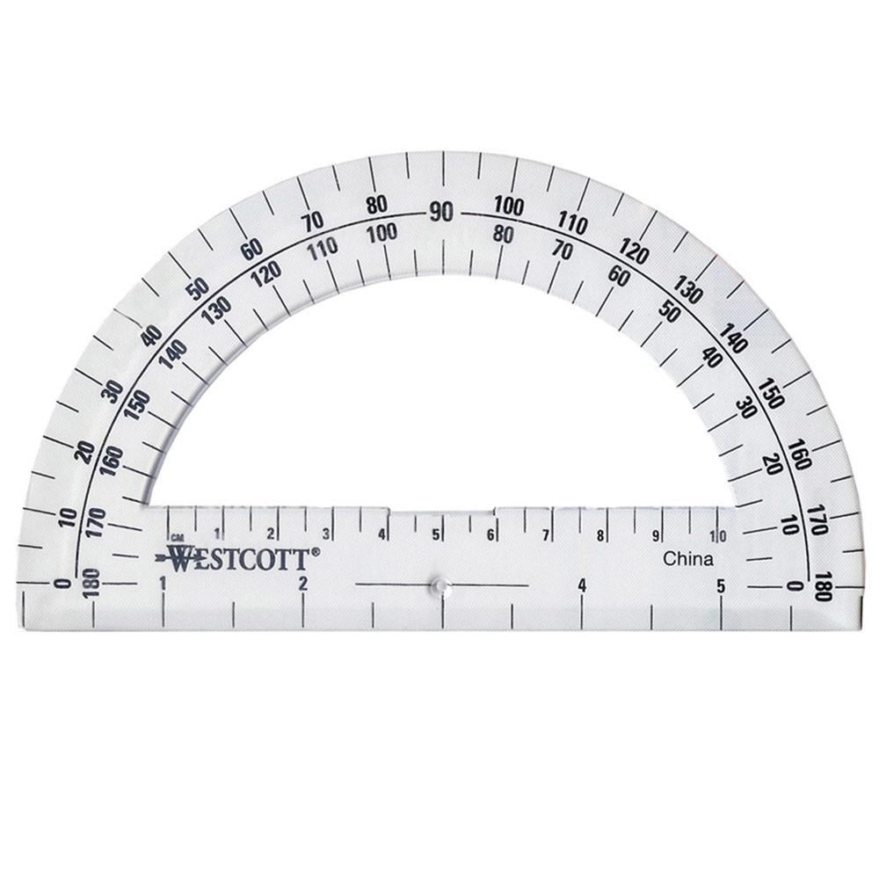
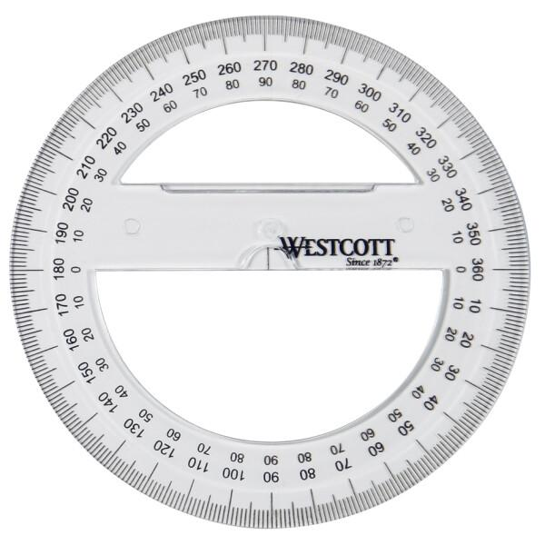
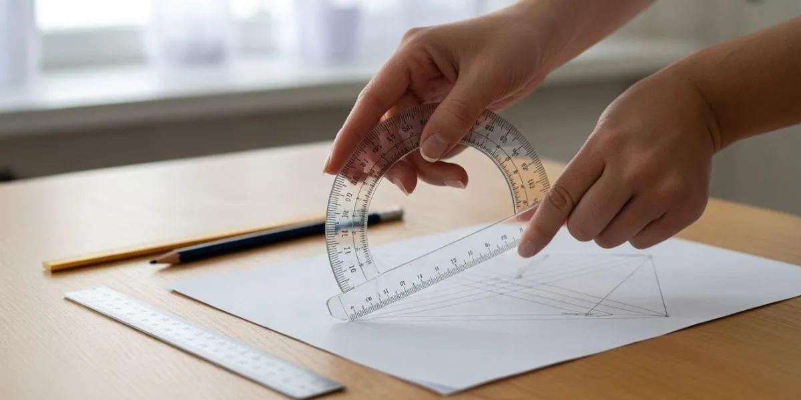
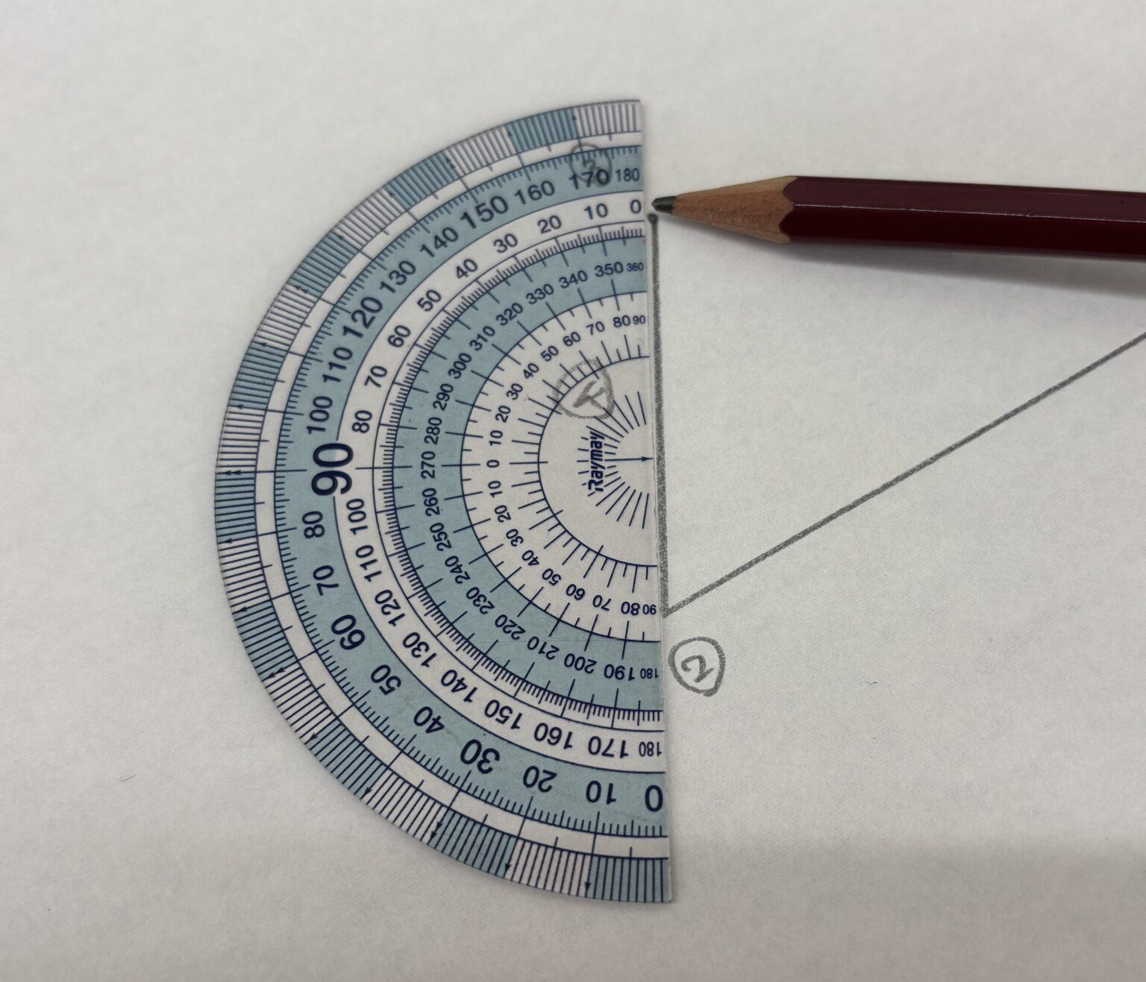
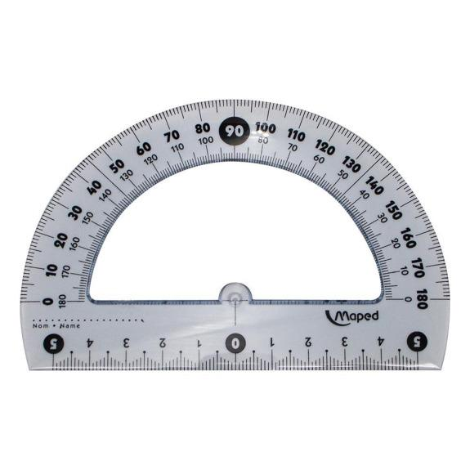
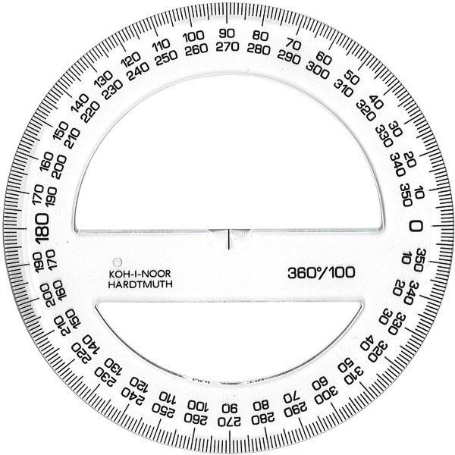
A Protractor is a measuring instrument used to measure and draw angles. It is one of the most common tools in geometry, mathematics, engineering, drafting, architecture, and technical drawing.
Most protractors are marked in degrees (°) and allow users to measure angles accurately from 0° to 180° or 0° to 360°, depending on the type.

Definition
# Source: AI Source: Provided by: [Data Path: Persons Table -> ID Column: 1, Name_En Column: Motasem Essam] -> From: [ChatGPT] on [7/17/2026]
A Protractor is an angle-measuring instrument graduated in degrees and used to measure, construct, and transfer angles.

Purpose
# Source: AI Source: Provided by: [Data Path: Persons Table -> ID Column: 1, Name_En Column: Motasem Essam] -> From: [ChatGPT] on [7/17/2026]
A Protractor is used to:
- Measure angles.
- Draw angles.
- Construct geometric figures.
- Verify angular dimensions.
- Assist in technical drawing.
- Perform engineering layout work.

Main Components
# Source: AI Source: Provided by: [Data Path: Persons Table -> ID Column: 1, Name_En Column: Motasem Essam] -> From: [ChatGPT] on [7/17/2026]
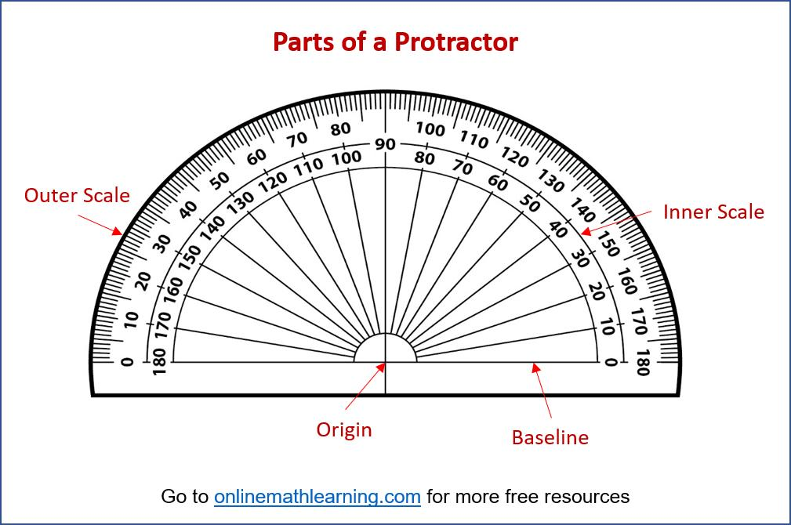
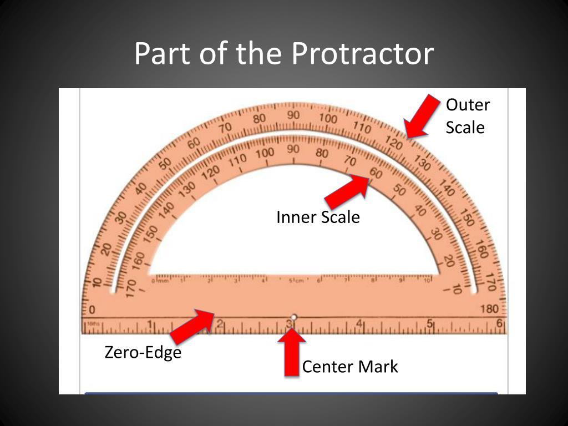
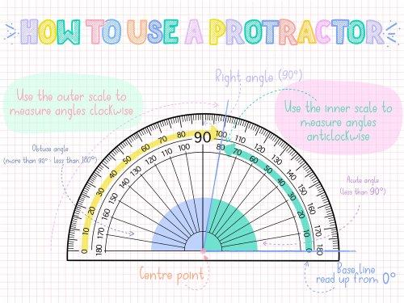
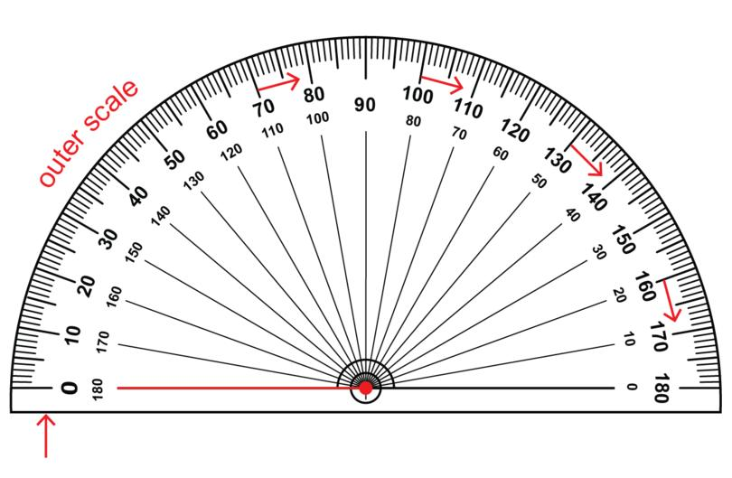
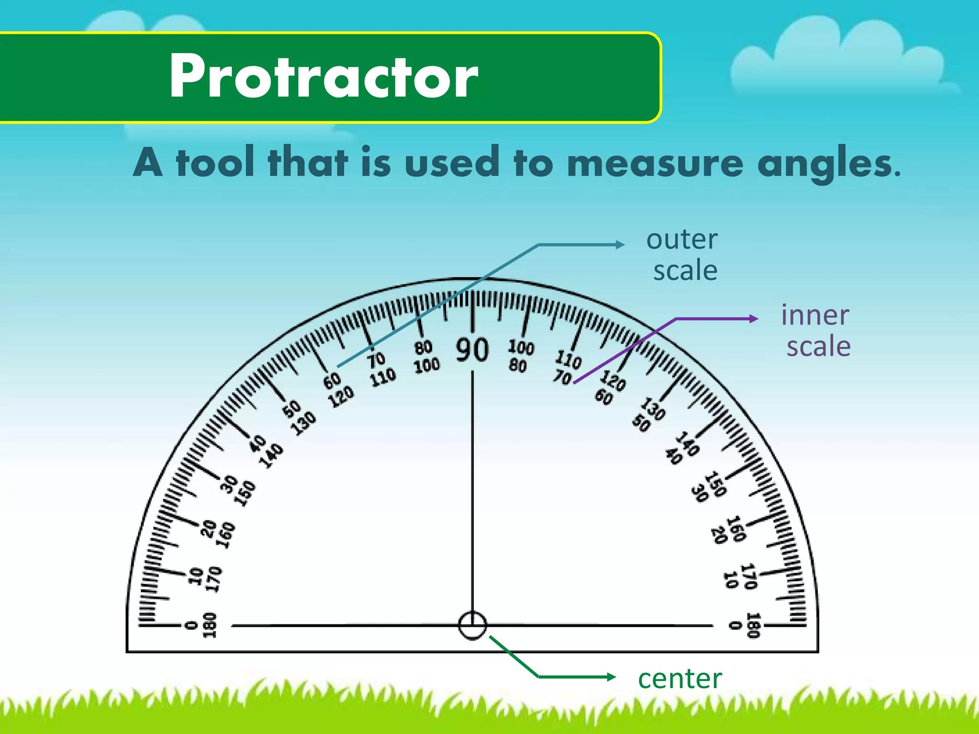
A typical protractor consists of:
- Center Point (Origin)
- Baseline
- Degree Scale
- Outer Scale
- Inner Scale
- Edge (Measuring Edge)

Types of Protractors

1. Semicircular Protractor (180°)
# Source: AI Source: Provided by: [Data Path: Persons Table -> ID Column: 1, Name_En Column: Motasem Essam] -> From: [ChatGPT] on [7/17/2026]
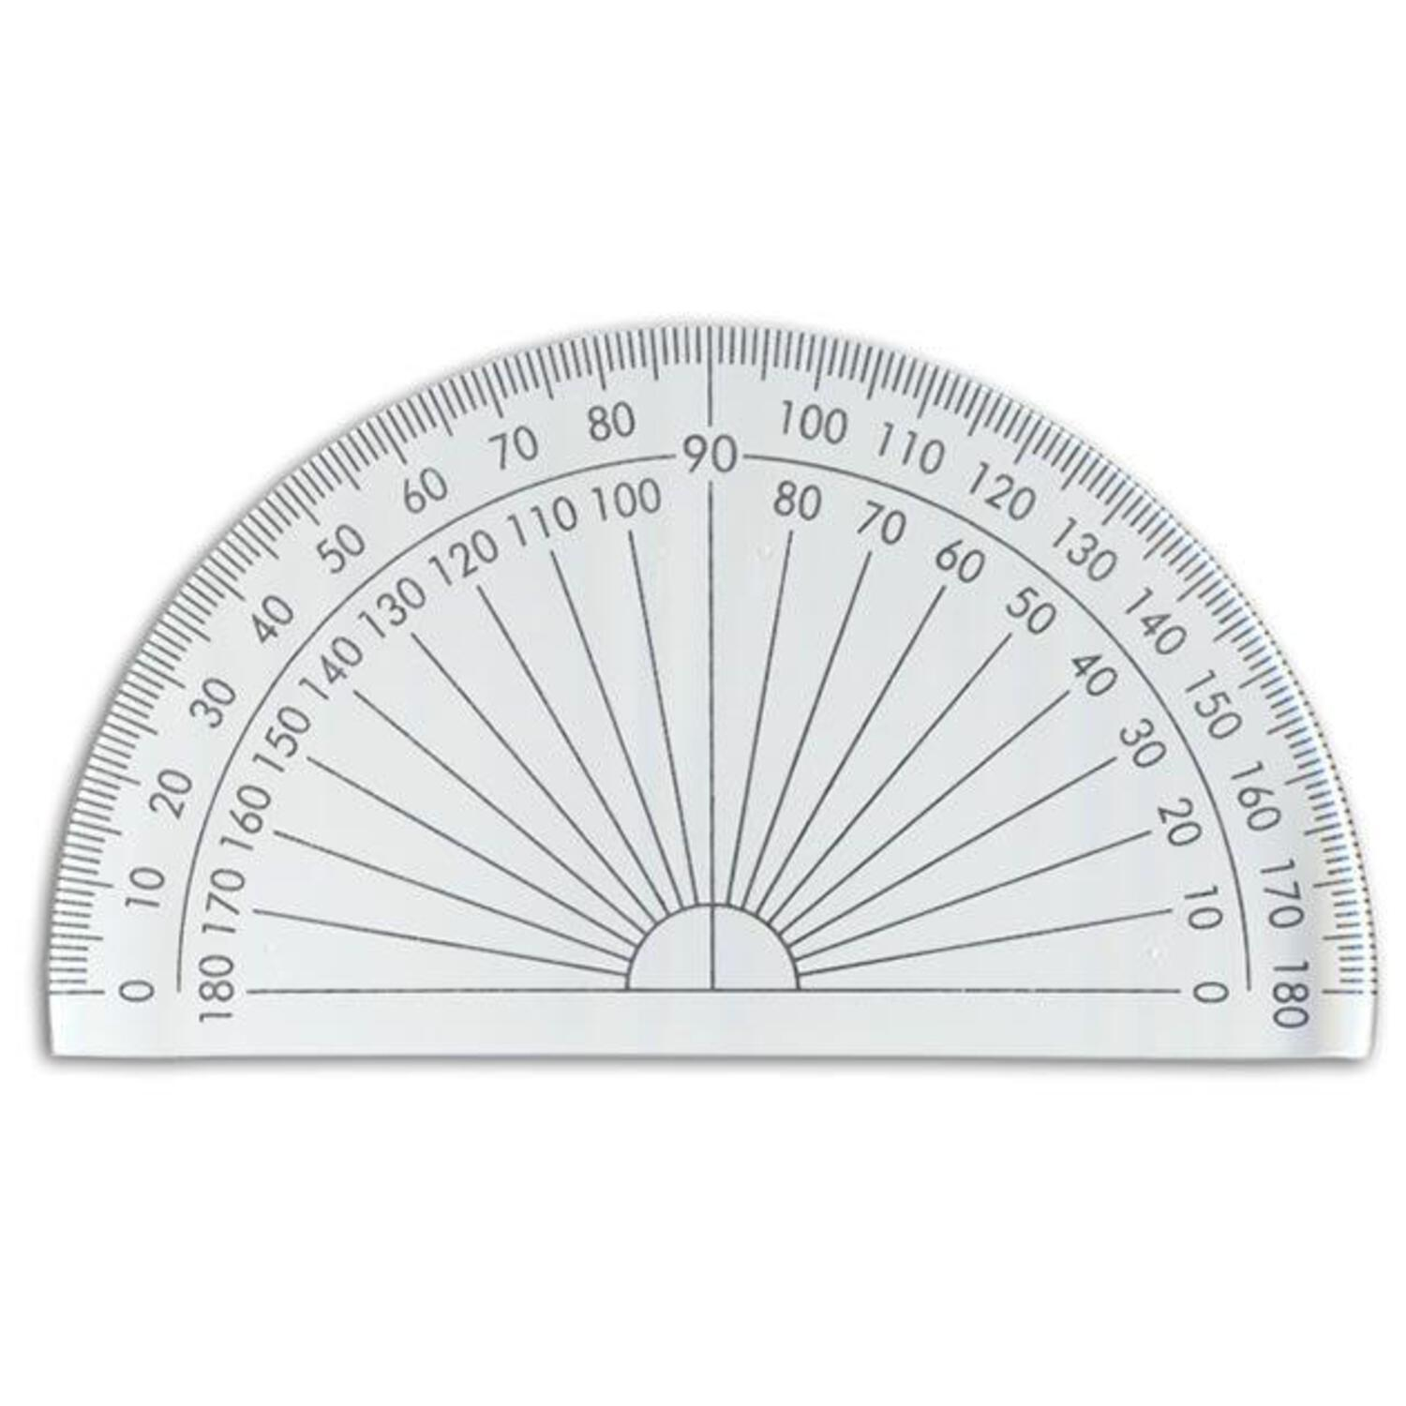
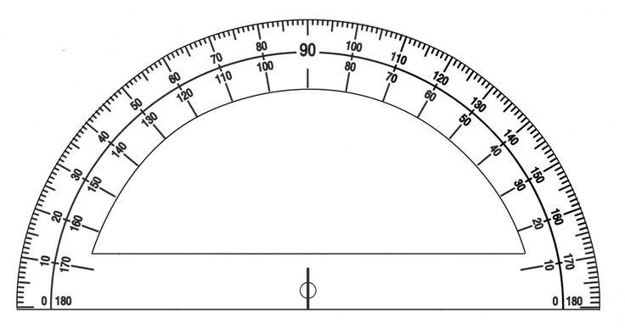
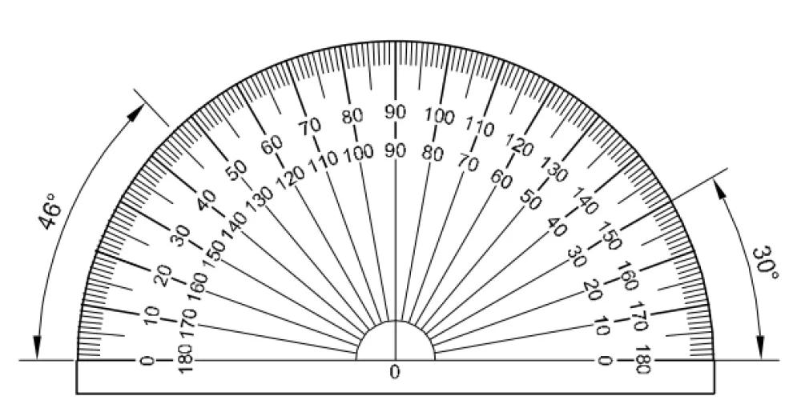
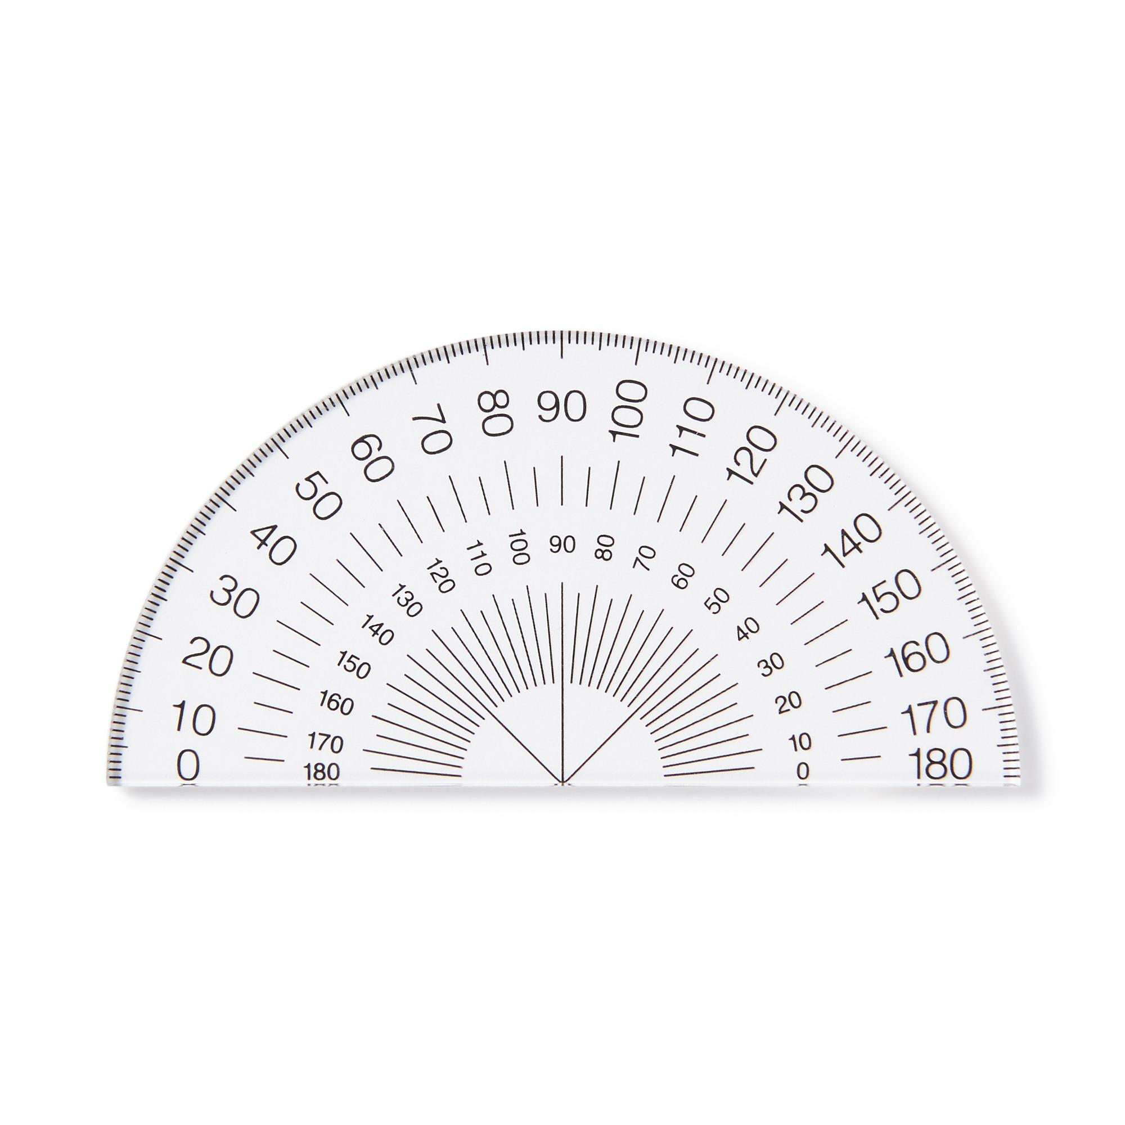
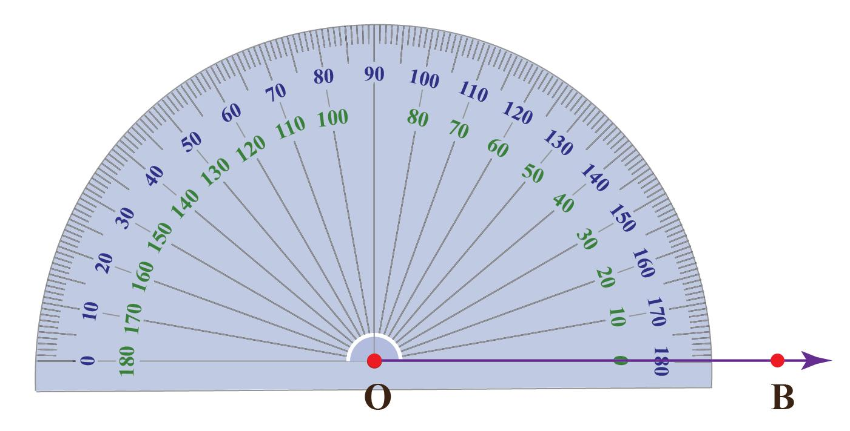
Description
The most common classroom protractor.
Measuring Range
- 0°–180°
Applications
- School mathematics
- Geometry
- Basic drafting

2. Circular Protractor (360°)
# Source: AI Source: Provided by: [Data Path: Persons Table -> ID Column: 1, Name_En Column: Motasem Essam] -> From: [ChatGPT] on [7/17/2026]


Description
Measures a full circle.
Measuring Range
- 0°–360°
Applications
- Engineering
- Surveying
- Navigation
- Advanced geometry

3. Adjustable (Bevel) Protractor
# Source: AI Source: Provided by: [Data Path: Persons Table -> ID Column: 1, Name_En Column: Motasem Essam] -> From: [ChatGPT] on [7/17/2026]
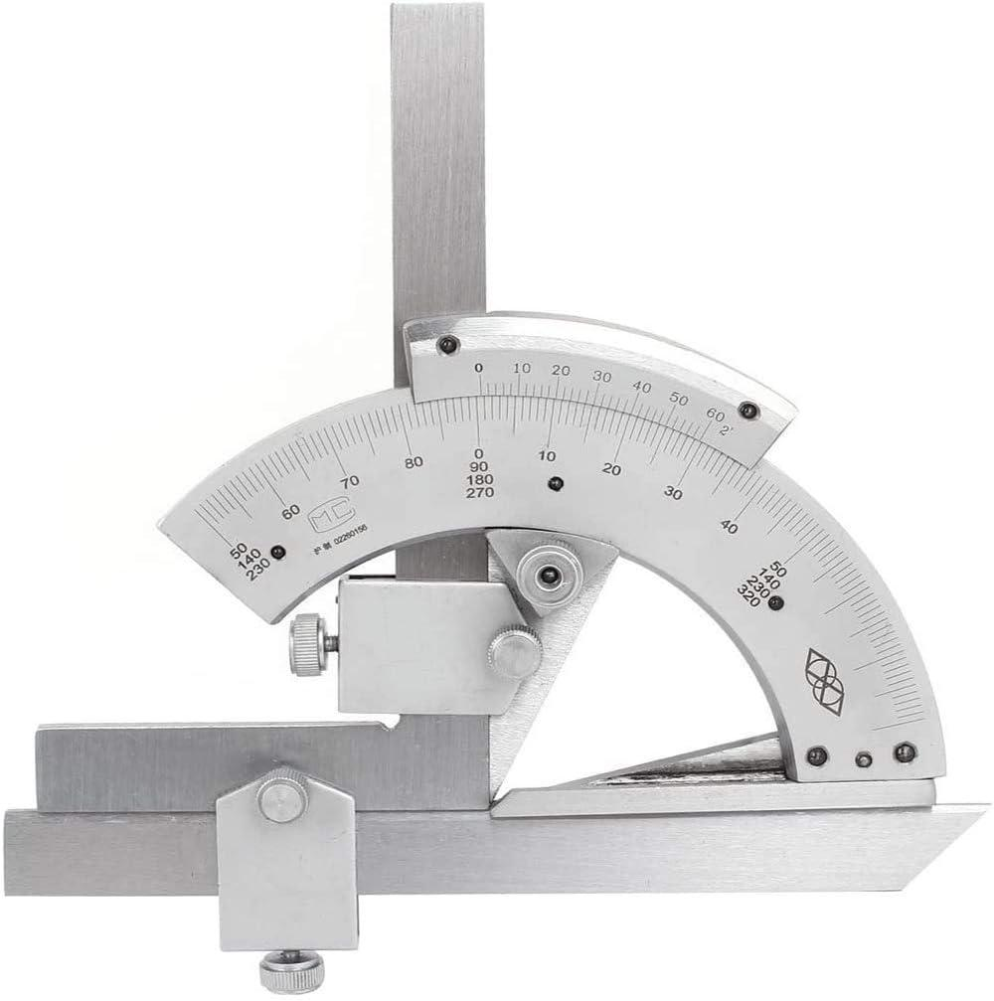
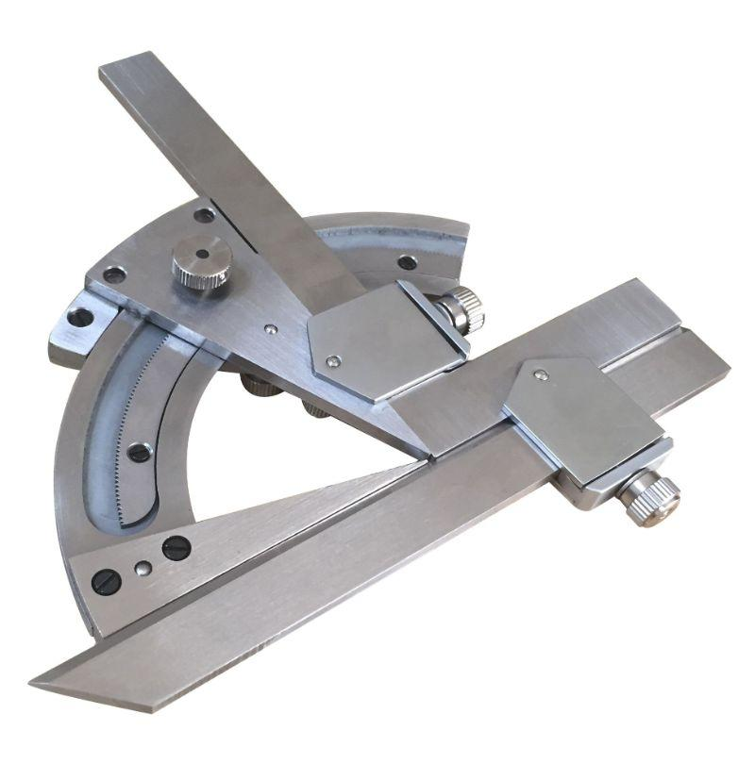
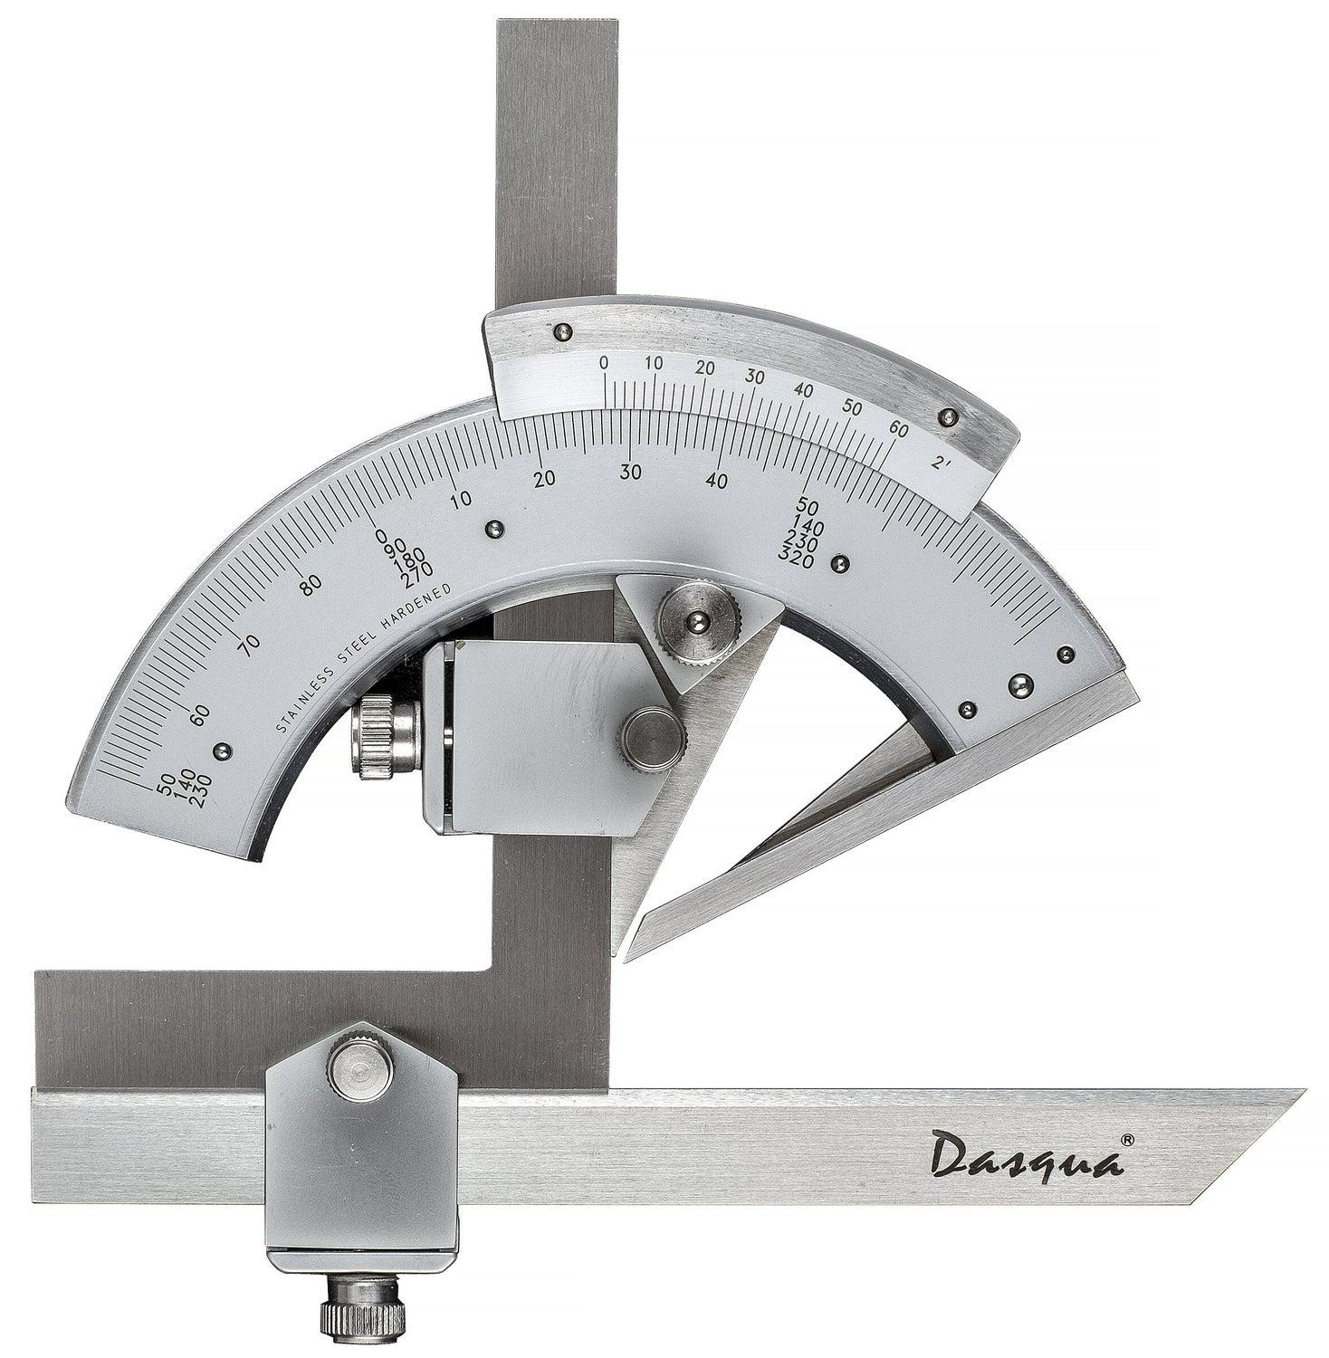
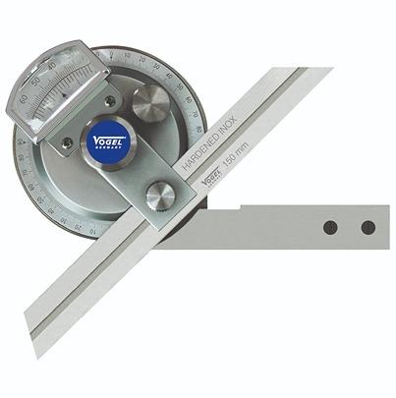
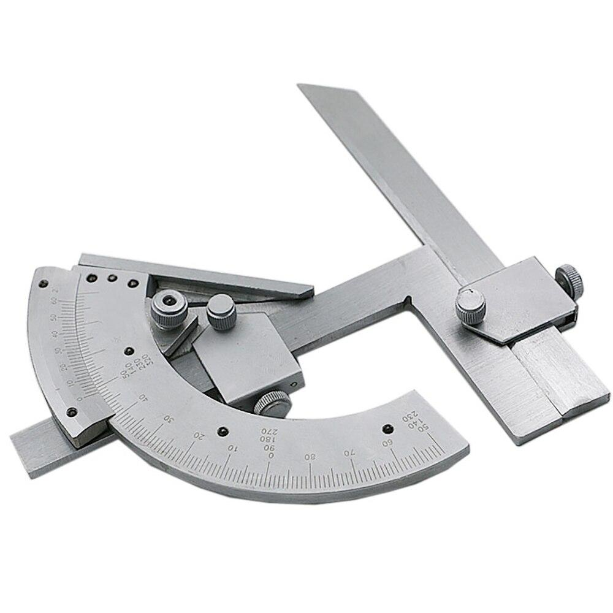
Description
A precision instrument with a rotating blade for measuring and setting angles.
Features
- Adjustable blade
- Locking mechanism
- Fine graduations
- High accuracy
Applications
- Mechanical engineering
- Machining
- Quality inspection

4. Digital Protractor
# Source: AI Source: Provided by: [Data Path: Persons Table -> ID Column: 1, Name_En Column: Motasem Essam] -> From: [ChatGPT] on [7/17/2026]
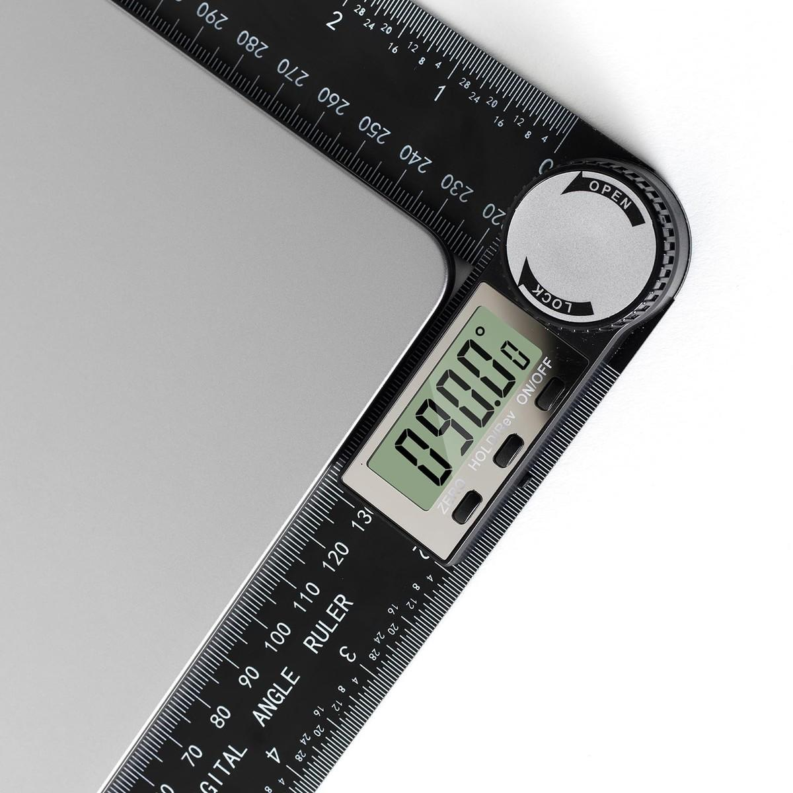
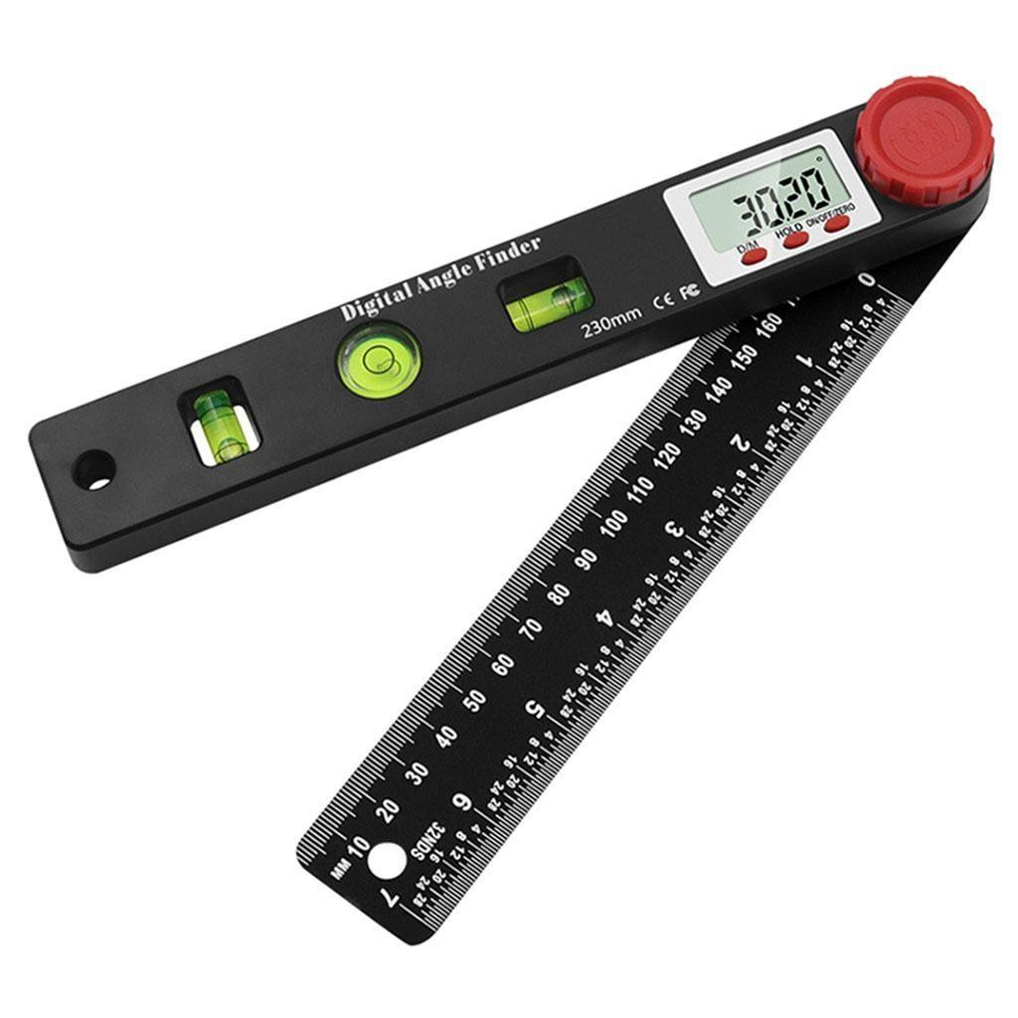
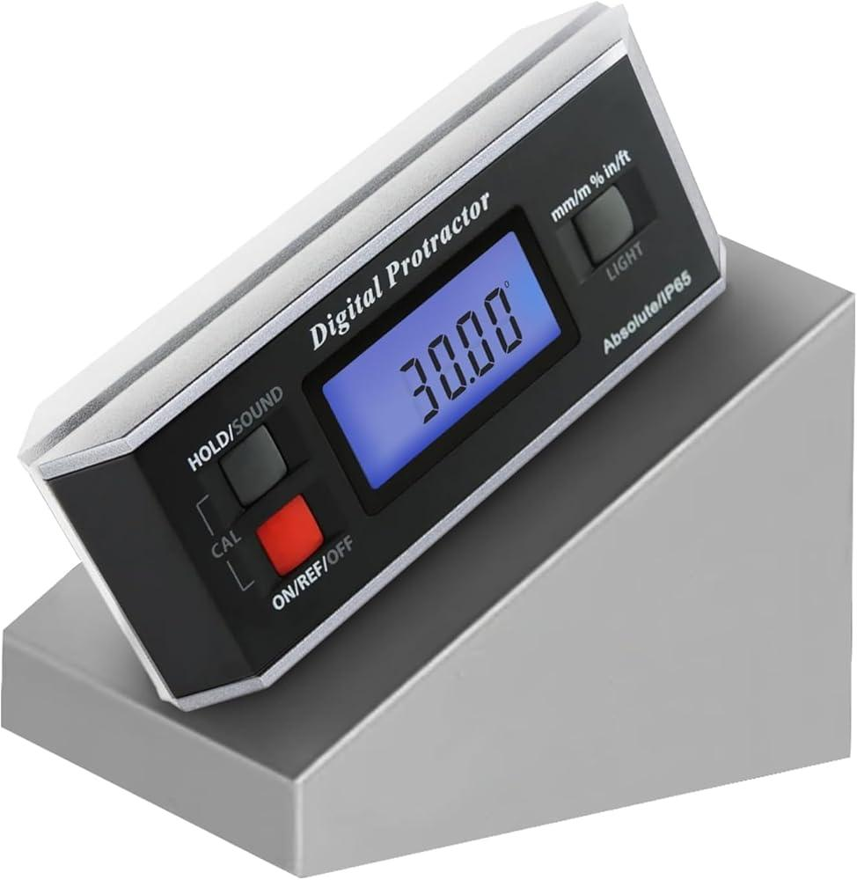
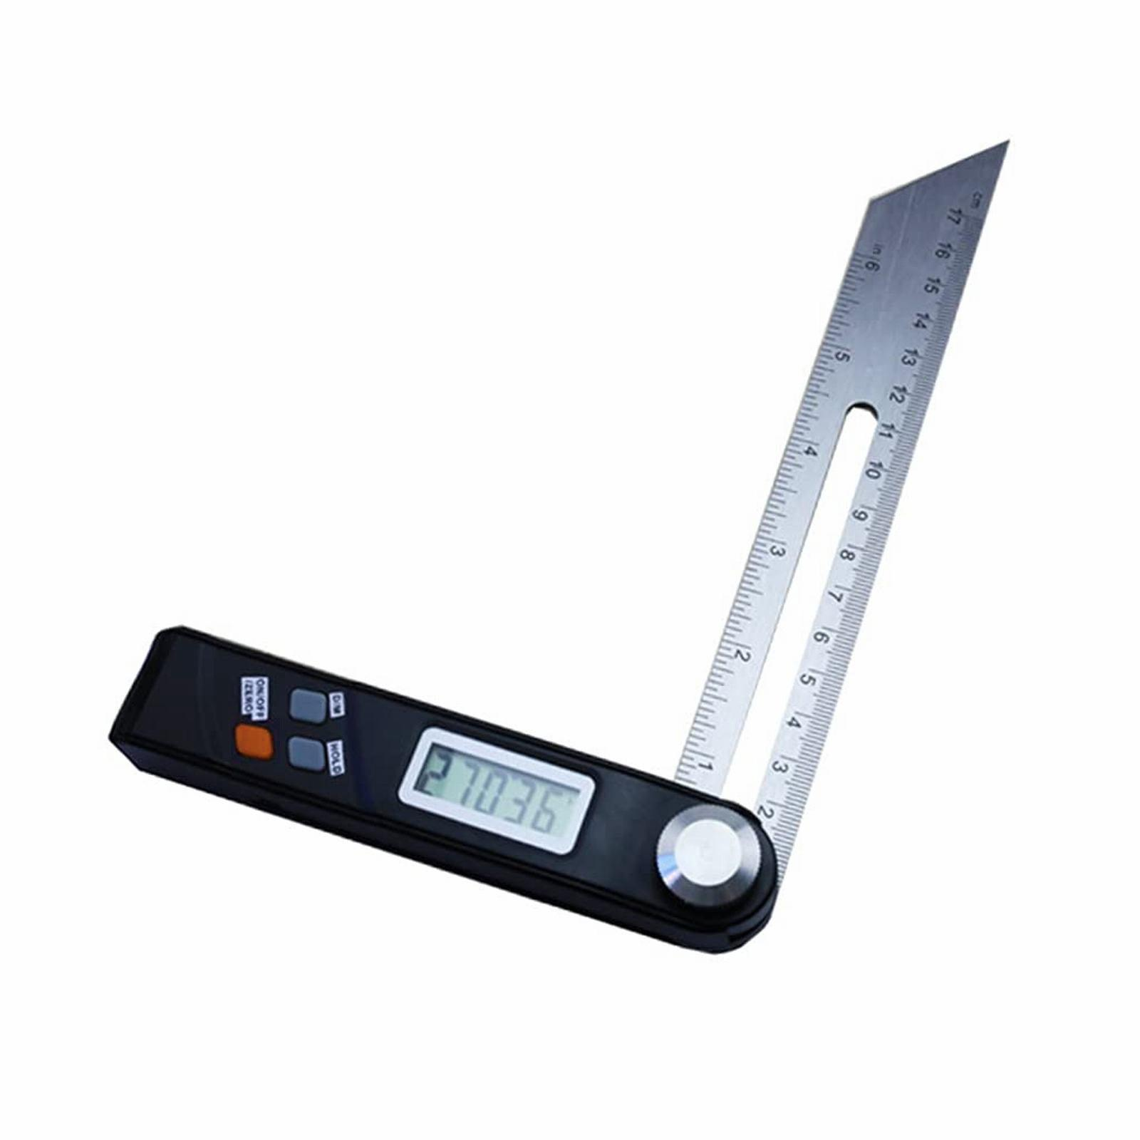
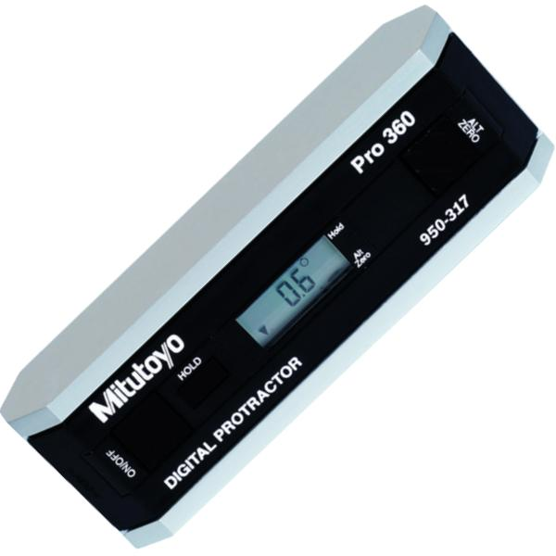
Description
An electronic protractor that displays angle measurements digitally.
Features
- LCD display
- High precision
- Digital readout
- Battery powered
Applications
- Construction
- Woodworking
- Manufacturing
- Precision engineering

Measuring Units
# Source: AI Source: Provided by: [Data Path: Persons Table -> ID Column: 1, Name_En Column: Motasem Essam] -> From: [ChatGPT] on [7/17/2026]
A protractor measures angles in:
- Degrees (°)
Some advanced instruments may also display:
- Minutes (′)
- Seconds (″)

Measuring Range
# Source: AI Source: Provided by: [Data Path: Persons Table -> ID Column: 1, Name_En Column: Motasem Essam] -> From: [ChatGPT] on [7/17/2026]
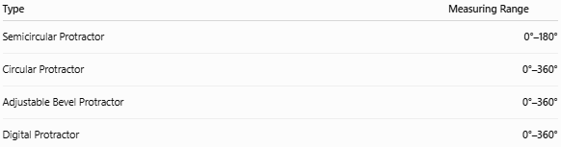
Type | Measuring Range
Semicircular Protractor | 0°–180°
Circular Protractor | 0°–360°
Adjustable Bevel Protractor | 0°–360°
Digital Protractor | 0°–360°

Resolution (Least Count)
# Source: AI Source: Provided by: [Data Path: Persons Table -> ID Column: 1, Name_En Column: Motasem Essam] -> From: [ChatGPT] on [7/17/2026]
Typical resolutions:
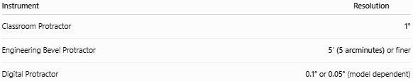
Instrument | Resolution
Classroom Protractor | 1°
Engineering Bevel Protractor | 5′ (5 arcminutes) or finer
Digital Protractor | 0.1° or 0.05° (model dependent)

How to Measure an Angle
# Source: AI Source: Provided by: [Data Path: Persons Table -> ID Column: 1, Name_En Column: Motasem Essam] -> From: [ChatGPT] on [7/17/2026]
- Place the center point of the protractor on the angle's vertex.
- Align the baseline with one side of the angle.
- Read the degree value where the other side crosses the scale.
- Record the measurement.

Example
# Source: AI Source: Provided by: [Data Path: Persons Table -> ID Column: 1, Name_En Column: Motasem Essam] -> From: [ChatGPT] on [7/17/2026]
Suppose the second ray intersects the scale at:
65°
The measured angle is:
$$\boxed{{65}^{∘}}$$

Accuracy
# Source: AI Source: Provided by: [Data Path: Persons Table -> ID Column: 1, Name_En Column: Motasem Essam] -> From: [ChatGPT] on [7/17/2026]
Typical accuracy:
- ±1° (standard plastic protractor)
- ±0.5° (precision models)
- Better for digital and bevel protractors
Accuracy depends on:
- Graduation quality
- Alignment
- User technique
- Instrument calibration

Sources of Error
# Source: AI Source: Provided by: [Data Path: Persons Table -> ID Column: 1, Name_En Column: Motasem Essam] -> From: [ChatGPT] on [7/17/2026]
Instrument Errors
- Worn graduations
- Damaged edges
- Manufacturing defects

Observation Errors
- Reading the wrong scale (inner vs. outer)
- Parallax error
- Incorrect degree estimation

Positioning Errors
- Center not placed exactly on the vertex
- Baseline not aligned correctly
- Instrument movement during reading

Applications
# Source: AI Source: Provided by: [Data Path: Persons Table -> ID Column: 1, Name_En Column: Motasem Essam] -> From: [ChatGPT] on [7/17/2026]
Protractors are used in:
- Mathematics
- Geometry
- Engineering
- Architecture
- Drafting
- Surveying
- Construction
- Woodworking
- Manufacturing
- Technical drawing

Advantages
# Source: AI Source: Provided by: [Data Path: Persons Table -> ID Column: 1, Name_En Column: Motasem Essam] -> From: [ChatGPT] on [7/17/2026]
A Protractor:
- Is simple to use.
- Is inexpensive.
- Measures angles quickly.
- Is portable.
- Is available in analog and digital forms.

Limitations
# Source: AI Source: Provided by: [Data Path: Persons Table -> ID Column: 1, Name_En Column: Motasem Essam] -> From: [ChatGPT] on [7/17/2026]
A Protractor:
- Has limited precision compared with specialized angular measuring instruments.
- Requires proper alignment.
- Plastic models may wear or deform over time.

Comparison with Other Angle Measuring Instruments
# Source: AI Source: Provided by: [Data Path: Persons Table -> ID Column: 1, Name_En Column: Motasem Essam] -> From: [ChatGPT] on [7/17/2026]
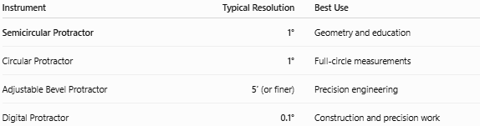
Instrument | Typical Resolution | Best Use
Semicircular Protractor | 1° | Geometry and education
Circular Protractor | 1° | Full-circle measurements
Adjustable Bevel Protractor | 5′ (or finer) | Precision engineering
Digital Protractor | 0.1° | Construction and precision work

Care and Maintenance
# Source: AI Source: Provided by: [Data Path: Persons Table -> ID Column: 1, Name_En Column: Motasem Essam] -> From: [ChatGPT] on [7/17/2026]
To maintain accuracy:
- Keep the graduations clean.
- Avoid scratching the scale.
- Store flat to prevent bending.
- Protect digital models from moisture.
- Replace damaged or cracked protractors.

Common Mistakes
# Source: AI Source: Provided by: [Data Path: Persons Table -> ID Column: 1, Name_En Column: Motasem Essam] -> From: [ChatGPT] on [7/17/2026]
- Using the wrong scale (inner vs. outer).
- Misaligning the baseline.
- Not placing the center exactly on the vertex.
- Reading from an angle, causing parallax.
- Measuring from the wrong reference line.

Key Points
# Source: AI Source: Provided by: [Data Path: Persons Table -> ID Column: 1, Name_En Column: Motasem Essam] -> From: [ChatGPT] on [7/17/2026]
- A Protractor measures and constructs angles.
- Most common types:
  - Semicircular Protractor (180°)
  - Circular Protractor (360°)
  - Adjustable Bevel Protractor
  - Digital Protractor
- Standard classroom resolution is 1°.
- Precision models provide finer resolution.
- It is widely used in geometry, engineering, drafting, architecture, and construction.

Conclusion
# Source: AI Source: Provided by: [Data Path: Persons Table -> ID Column: 1, Name_En Column: Motasem Essam] -> From: [ChatGPT] on [7/17/2026]
A Protractor is one of the most widely used instruments for measuring and constructing angles. Whether in classrooms for teaching geometry or in engineering workshops for technical layout, it provides a practical means of determining angular measurements. While standard semicircular and circular protractors are ideal for educational and general-purpose work, adjustable bevel protractors and digital protractors offer significantly higher precision for industrial, manufacturing, and engineering applications.

